Your Band  
NEWSLETTER

October , 2018

# Campus selections

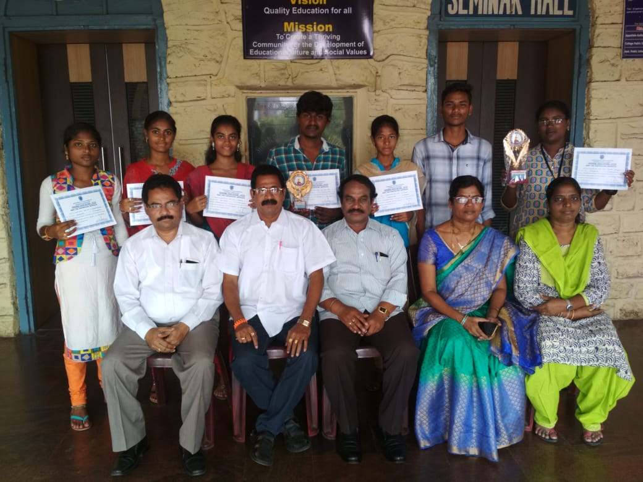

## Congratulations!